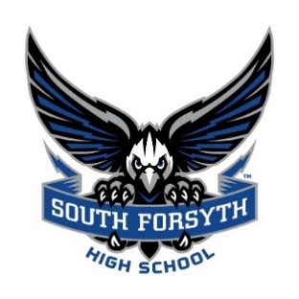 Lady War Eagle Member GHSA

Varsity & JV Basketball Region 6-AAAAAAA

2024 - 2025 Schedule * Region Games/**Bold-** -Home Games

TENTATIVE

November Opponent/Location JV Varsity

**Tuesday- 5 Lanier HS (*Scrimmage*) 6:00**

Saturday- 9 Woodstock @Sequoyah Jamboree TBA

Thursday- 14 @Lanier 4:30 PM 6:00 PM

Saturday- 16 Mount Bethel *@Cherokee HS*.- ***Wood Elite Tip-off Classic*** 10:00 AM

**Tuesday- 19 Fideles Christian 6:00 PM**

Friday- 22 @Dacula 4:30 PM 6:00 PM

23 & 25 @North Hall HS Tournament TBA

Saturday-30 Walton @Cherokee HS- ***Wood Elite Thanksgiving Showcase*** 12:00 PM

December

**Tuesday -3 *West Forsyth 4:30 PM 6:00 PM**

**Friday - 6 *North Atlanta 4:30 PM 6:00 PM**

**Saturda-7 Horizon Christian *(Saturday Santa Shootout I)* 2:30 pm**

Tuesday - 10 * @Forsyth Central 4:30 PM 6:00 PM

**Friday- 13 *Denmark 4:30 PM 6:00 PM**

Saturday-14 @North Forsyth 1:00 PM 4:00 PM

**Friday-20 Peachtree Ridge 3:30 PM**

January

Friday - 3 @North Gwinnett 5:00 PM 6:30 PM

**Saturday-4 Chattahoochee 3:00 pm 4:30 PM**

**Tuesday-7 * Alpharetta 4:30 PM 6:00 PM**

**Friday-10 * Lambert 4:30 PM 6:00 PM**

Tuesday- 14 *@West Forsyth  4:30 PM 6:00 PM

Friday-17 @North Atlanta 4:30 PM 6:00 PM

**Tuesday- 21 * Forsyth Central 4:30 PM 6:00 PM**

Friday- 24 * @Denmark 4:30 PM 6:00 PM

**Tuesday- 28 *North Forsyth 4:30 PM 6:00 PM**

Friday- 31 @Alpharetta 4:30 PM 6:00 PM

February

Tuesday- 4 *@Lambert 4:30 PM 6:00 PM

7th, 8th, 11th, 13th Region Tournament @ Alpharetta High School TBD

**State Tournament** **TBD**

**Principal**: Pam Bibik

**Head Coach**: Keith Gravitt

**Assistant Coaches**: Kyle Turner, Erica Belson

**Manager**:

**Video:**